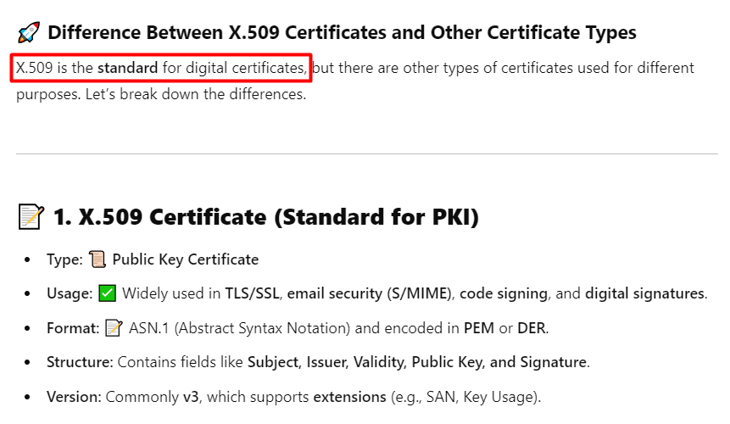
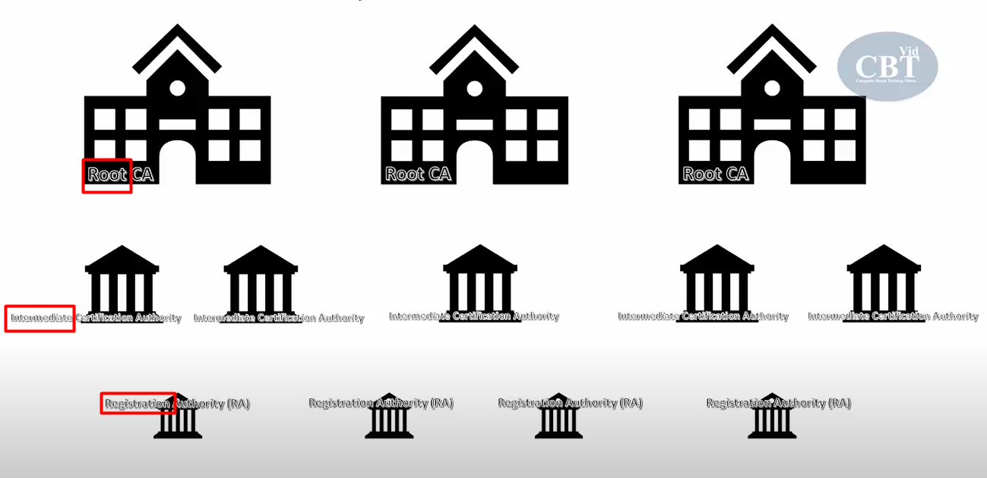

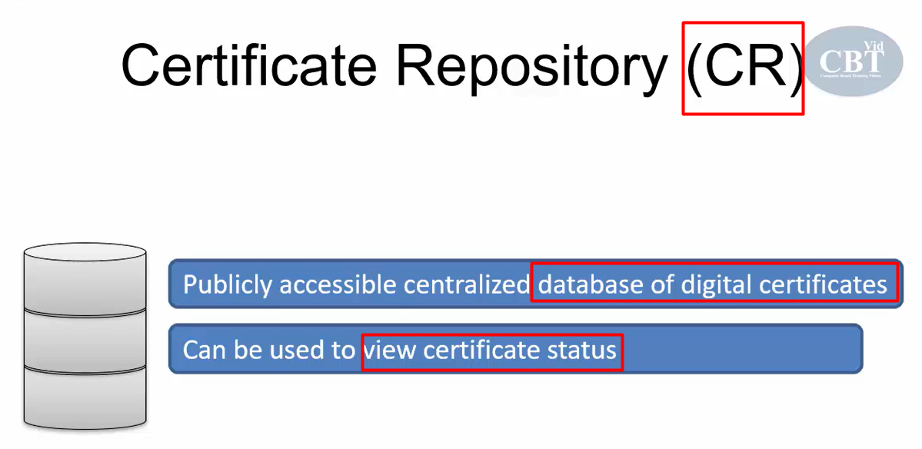

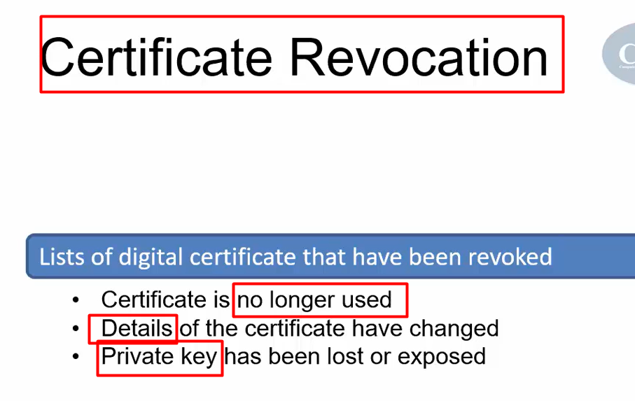
- 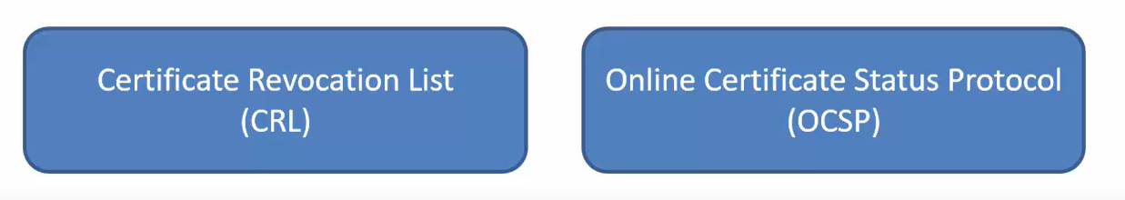
To check whether a digital certificate is valid or not

===
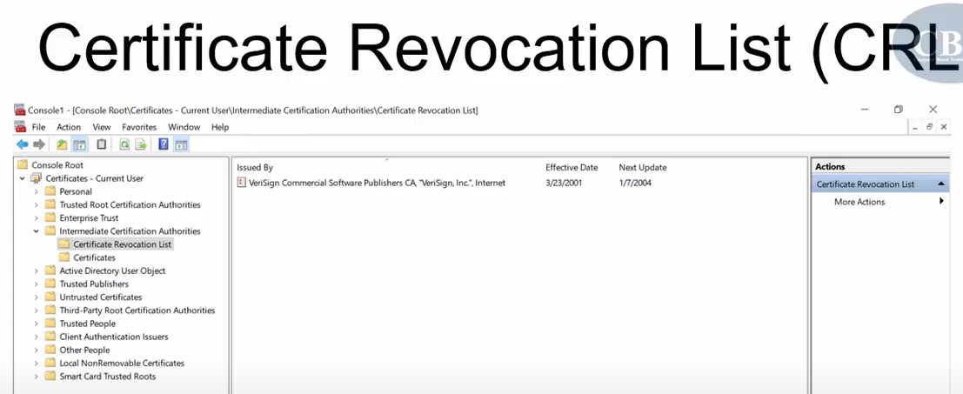
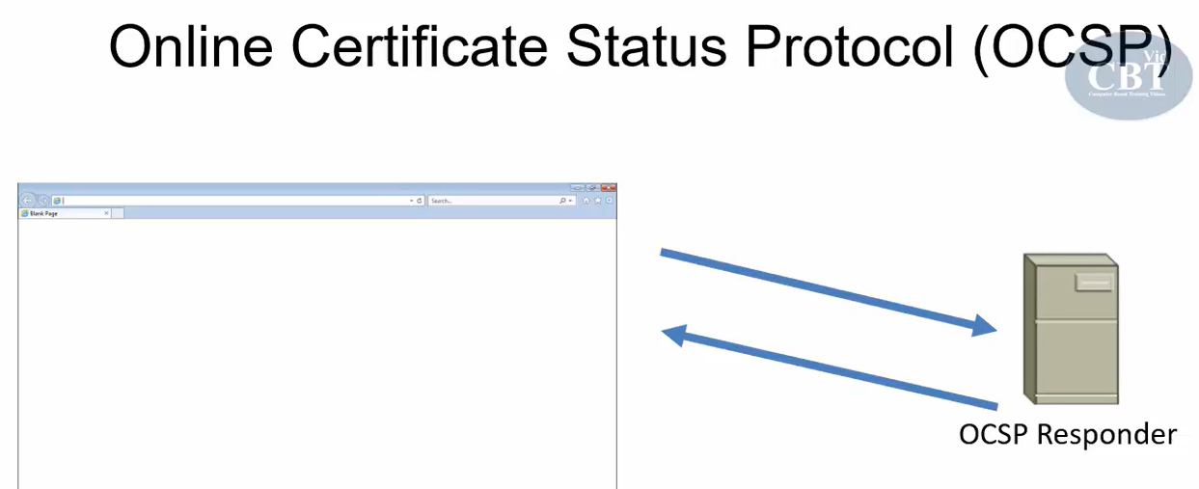
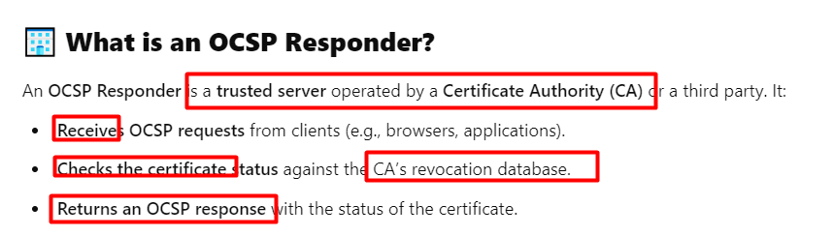

==
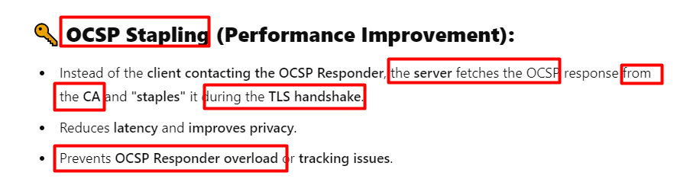
Difference between OCSP and OCSP stapling

Client -> OCSP responder
Server -> ask OCSP responder -> response (signed)
OCSP stapling : OCSP response + cert -> Client for verifying both

